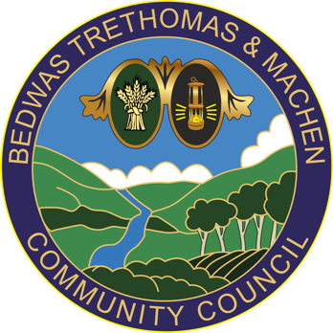
Bedwas, Trethomas & Machen Community Council
Council Offices
Newport Road
Bedwas
Caerphilly
CF83 8YB
Tel: (029) 2088 5734
E-mail: clerk@btmcc.co.uk

10th May 2021

To: All Members of BTMCC Land & Building Management Committee

You are summoned to attend a meeting of ‘LAND & BUILDING MANAGEMENT COMMITTEE’ to be undertaken by remote access using MS Teams to be held on Tuesday 18th May 2021 at 3pm.

If you are unable to attend this meeting, please send your apologies to clerk@btmcc.co.uk or telephone (029) 20885734 prior to the meeting.

In line with legislation, community council meetings are open to members of the public and press to attend.
Please contact BTM Council Offices in advance to request joining instructions.
Members of the press and public can attend on an observation basis only and
are not permitted to speak during the meeting.

The business to be transacted is set out in the agenda below. If any member requires further information on any item, please contact BTM Council Offices prior to the meeting.

Yours sincerely,

Cllr Amanda McConnell
Chair, Land & Buildings Management Committee

Page 1 of 2
Remote Land & Building Management Committee

AGENDA

1. To note those present and apologies

2. Declarations of Interest

3. To receive and confirm the minutes of the LBMC on 16th March 2021

4. Matters Arising (not on the Agenda) from the LBMC on 16th March 2021

BTM OFFICE, including Community Garden

5. To review the current contracts and inspection schedule BTM Office

6. To note actions and progress undertaken at the BTM Office since last meeting

7. To review the BTM Office Action Plan of planned maintenance & improvements/ refurbishment and agree next steps.

BEDWAS WORKMEN’S HALL

8. To review the current contracts and inspection schedule BWH

9. To note actions and progress undertaken at the BWH since last meeting

10. BWH emergency call out for intruder alarm – May 2021 – quote - H3Group 5882 - £194:72 plus VAT

11. To review the BWH Action Plan of planned maintenance & improvements/
refurbishment and agree next steps.

12. AOB

13. Date of next meeting

Page 2 of 2

